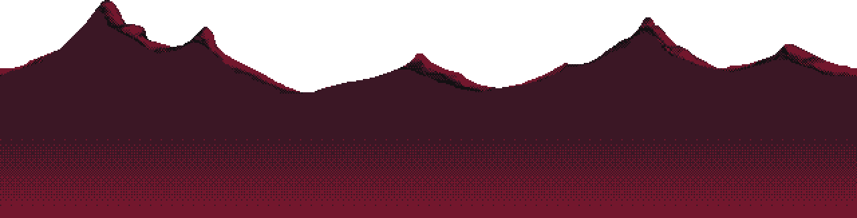

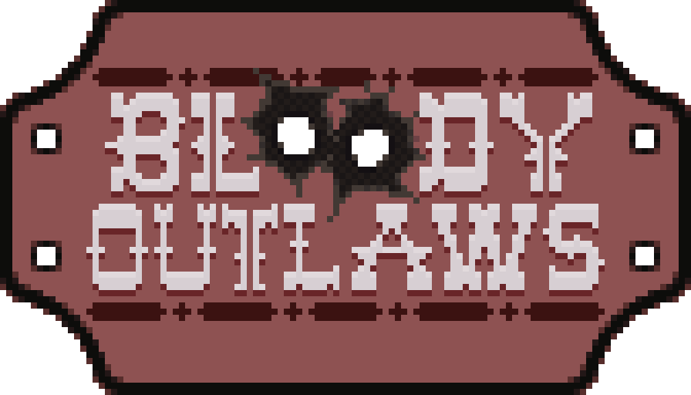

Game Design Document

by Tembani Mdaya (B00345574)  
&  
Taylor Moon (B00420625)

Contents

Game Design 2

Game Overview 2

Game Concept 2

Inspiration 2

Time Crisis 3

Operation Wolf 3

Blood Bros. 3

Wild Guns 3

Plot 3

Gameplay 3

Game Interface Design 4

Game Environment/ Level Design 4

Enemies 5

Game Implementation 5

Game Features 6

Gameplay & Player Mechanics 6

Project Management 6

References 7

# Game Design

## Game Overview

Project Gunning Wild (Working Title) is a 2D rail shooter set in the American Wild West.  
You’re a top-shot gunner travelling the desert and looking for whole towns to challenge, simply to test your limits.

You’ll be faced with all sorts of enemies, ranging from your normal barflies to weirdos with peculiar gunmanship. The core of the game will be speed and style.  
Speed being that you should take out enemies before they overwhelm you. This would also bring strategy to the game as you’d have to think of which enemy to take out first to move-on efficiently.

The target audience for the game would be people who like arcade shooting games.

## Game Concept

We got the idea from looking back at old-school arcade shooter games (more details on the “inspiration” section).  
It was also a simple concept that we could build on quick and easy.

### Inspiration

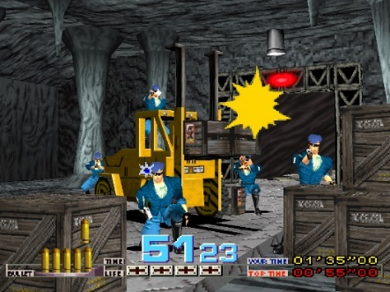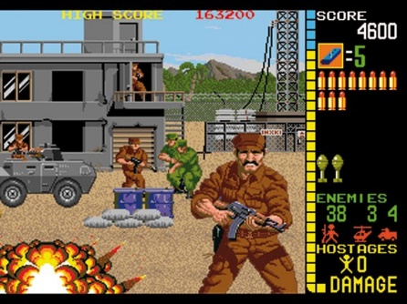Project Gunning Wild takes inspiration from target-shooting style games like Time Crisis, Operation Wolf, Blood Bros., and Wild Guns. These games have a light-hearted feel and look to them so our game should do the same.  
The control scheme would focus more on the 2D games like Blood Bros as that would be easier to develop for on a website.

Time Crisis by Namco (1995)

Operation Wolf by Taito (1987)

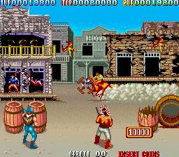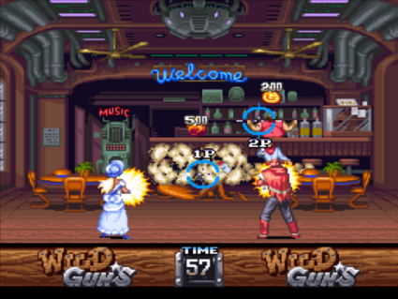

Blood Bros.   
by TAD Corporation (1990)

Wild Guns by Natsume (1994)

### Time Crisis

Time Crisis is a 3D on-rail arcade shooter that was mainly developed for Arcade Machines but was later ported to Home Consoles, namely the PlayStation 1, and I picked this as an inspiration because of how well it does it’s visual and gameplay to make the game seem more fun that it probably is.

The game’s use of fast camera movement to intensify the action whilst having dramatic animations on the enemies adds a lot of fun to the game and we thought we could incorporate that into our game.

### Operation Wolf

Operation Wolf is a 2D arcade rail-shooter developed by released in 1987 on Arcade Machines but later ported to Home Consoles and PC’s (NES, Master System, ZX Spectrum, Commodore 64, etc).  
Operation Wolf has you playing a soldier shooting enemy forces and military to rescue hostages.  
This game was picked as an inspiration because of the way they make enemies appear on the screen from both the sides of the screen and in the environment shown on the screen.

### Blood Bros.

Blood Bros. is a 2D arcade rail-shooter developed by TAD Corporation released in 1990 on Arcade Machines and NES.   
Blood Bros. is a relatively old game but has an interesting idea as to bring side-scrolling to the gameplay which is rather unique by giving the player a sense of freedom when it comes to positioning your self in the world instead of being forcibly stuck in one spot on the level.

### Wild Guns

Wild Guns is a new one I found as it was recently ported to the modern console, Nintendo Switch, and I’ve been able to play it and see for myself as to why it’s fun.

The game essentially takes the last 3 games and combines their ideas into a neat modern package.

## Gameplay

The game will be played like a mix between a side-scroller and on-rail.   
You’ll have to kill the enemies in the specific area you’re on so you can move onto the next.   
They’ll be a mid-point in the level which will be our shop where you’re able to buy health or upgrades on your weaponry.

Your typical level should play as 3 sections of the town (3 buildings) and then the sheriff building (Level Boss).  
After 2 sections, you get to go to the town’s shop to upgrade your gear or replenish health.  
Each section should last around 30 Seconds to 1 minute of fighting, or you kill at least 9-12 enemies before proceeding.  
As for the enemies, they can spawn behind cover like barrels and boxes or behind walls or maybe windows from buildings. They’ll be 3-4 enemies in total spawned but there should be only 1-2 of them peeking out at the same time.

The game will play out as a target-shooter where you mainly use your mouse throughout the game.  
You’ll shoot your gun with the Left-Click and Reload with the Right-Click. As for defence, you will shoot the enemies bullets out of the air before they reach you or tap an arrow key to dodge the bullets (not a final decision as we could just pick one over the other or not have it be a “dodge” mechanic).

## Game Interface Design

(Give information on the UI that will be used within your game, you might not have design at the stage of Assessment 1 but discuss the initial designs, you might want to include some screenshots/ scans of prototype sketches you have made for the UI)

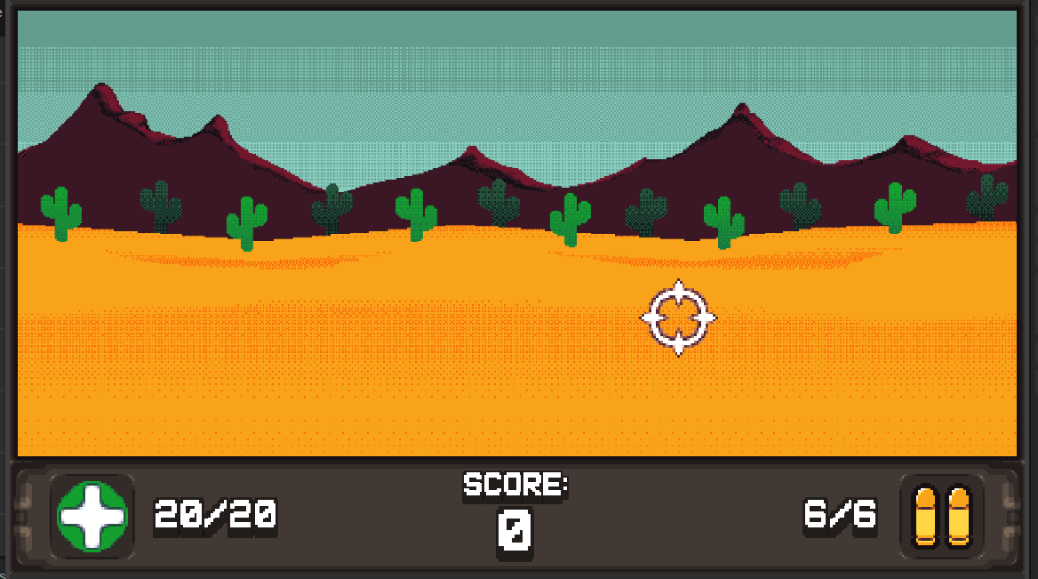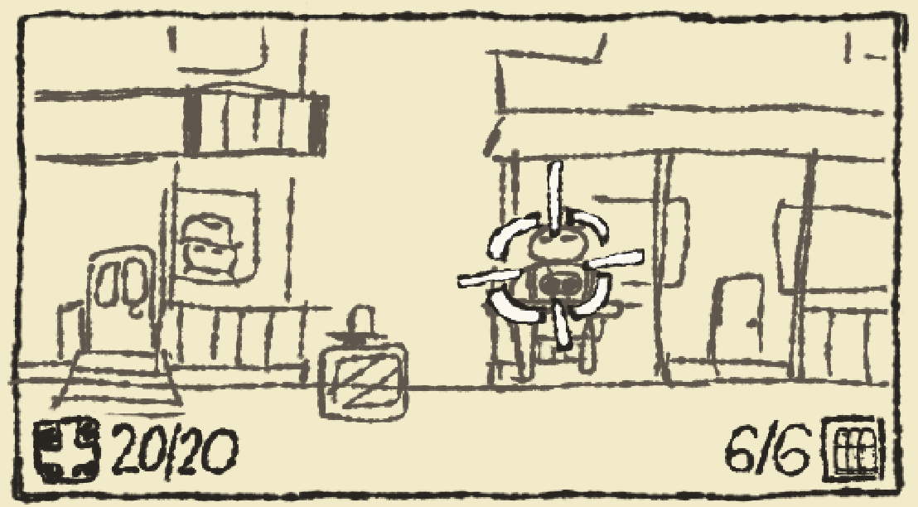The game’s UI would be a mixture of Time Crisis and Blood Bros. for placement and information shown.

Pertinent information like health, cash and ammo should be placed at the bottom so that it doesn’t clutter the player’s view when aiming/shooting at the enemies. We could change this to be more on the centre rather than placing them in corners if it’s necessary at the time.

## Game Environment/ Level Design

(Talk about your game environment, what will be your design choice behind your general game environment. Are there any games in the industry that you took inspiration from? Show sketches of levels and environments that are included in your game, describe the level and environment and what objects are within it. Show some prototype or final assets you may use; characters, environment tiles, enemies etc.)

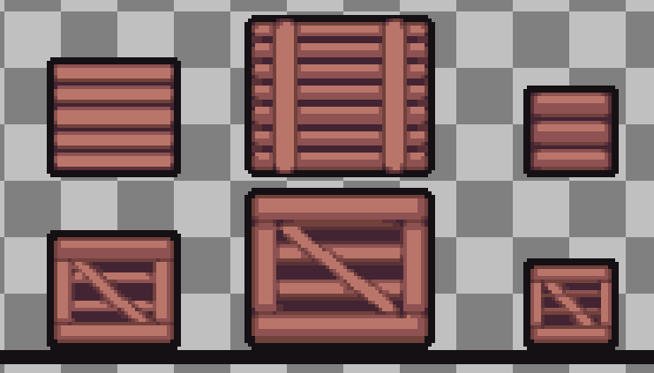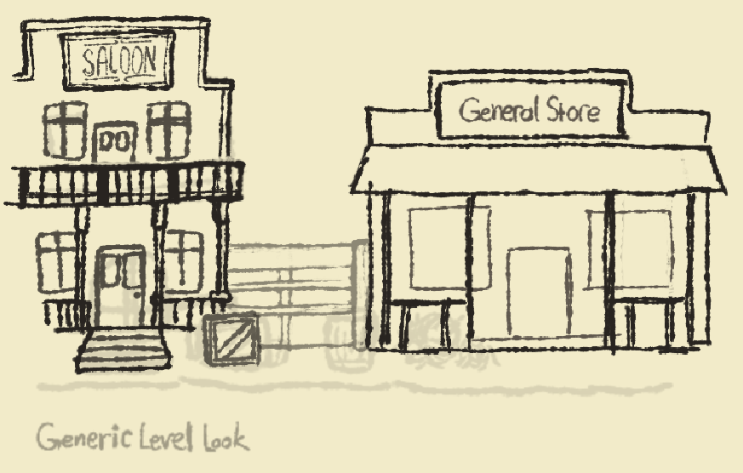

The game will be mainly based on the Wild West when it comes to look and sound.  
The general level design would be wide, linear levels that gradually getting more complicated into each section (more cover positions for enemies to hide behind).

## Enemies

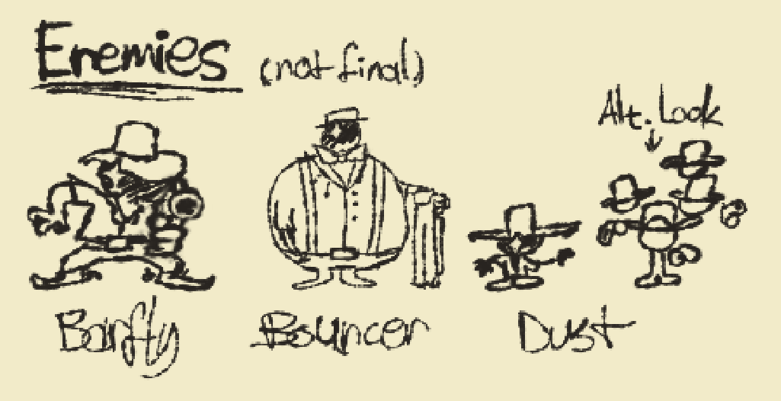

Barfly is a normal-sized, common enemy with nothing special going on. They pop out of cover or from the side of the screen and shoot a few times until going back under.  
  
Bouncer is a large-sized enemy that is harder to kill as they would have much more health. They also wield a heavier gun than Barfly which does more damage. They’re disadvantage would be that they are slow so they stay out of cover longer.

Dust is a small-sized enemy that would be the counterpart to Bouncer. They can move fast, allowing them to go in and out of cover quicker and generally anything else using speed. They’re disadvantages would be that they are also very weak, essentially one-hit to take them down. They also deal very little damage but that makes taking care of them an incentive as they could accumulate more damage the longer they live. Considering their general effectiveness, they would come in pack of 2 or more.

# Game Implementation

## Game Features

The game will be styled in animated pixel art produced in Aseprite along with parallax scrolling in the background.

The game will be made in widescreen (16:9) which will be unique from the inspirations used for this game.  
With the extra real-estate, we’ll be able to add more objects on the screen.  
  
Enemy bullets can be shot out of the air before they reach you.  
The game should feature a combo system which takes account to shooting enemies and shooting bullets.  
Currently, the unique feature in our game would be the mid-point shop and the weapon upgrades.

## Gameplay & Player Mechanics

The game will be played with a mouse as the main controller for the shooting and reloading appointed to Left Click and Right Click respectably.

You can dodge bullets by pressing the arrow keys.  
You can also shoot out the bullets before they reach you.

# Project Management

Tembani will mainly handle the graphics/looks of the game. Lead Game Designer.  
Taylor would handle the general programming of the project. Programmer.

They aren’t strict roles so we could help ourselves in both sections.  
I’m in the middle of making a Gantt-style chart but I’m still fine-tuning it.

# References

*(All references will go at the end.* ***Good to also include appendices.****)*

*Namco (1995) Time Crisis [Video game]. Sony Interactive Entertainment Europe*

*Operation Wolf (1987) – Made by Taito  
Taito (1987) Operation Wolf [Video game]. Taito*

*Blood Bros. (1990) – Made by TAD Corporation  
TAD Corporation (1990) Blood Bros. [Video game]. TAD Corporation*

*Wild Guns (1994) – Made by Natsume  
Natsume (1994) Wild Guns [Video game]. Natsume*

*Section E12.1 in CTR Harvard*